Guest Lifecycle Sentiment Dashboard
Operational Summary Report
Mahesh Sambare | Portfolio Project | Data: Booking.com Reviews, Europe (2015–2017)

1. What This Looks At
We were given 515,738 guest reviews from 1,493 hotels and asked to find out where the guest experience actually breaks down not just whether guests are happy, but at which point in their stay things go wrong, and why.
Every review was split by stage of the guest journey: before arrival, at check-in, during the stay, at checkout, and after the stay. That way, instead of one big “guests are unhappy” number, we can see exactly where the problem sits and fix that specific point.

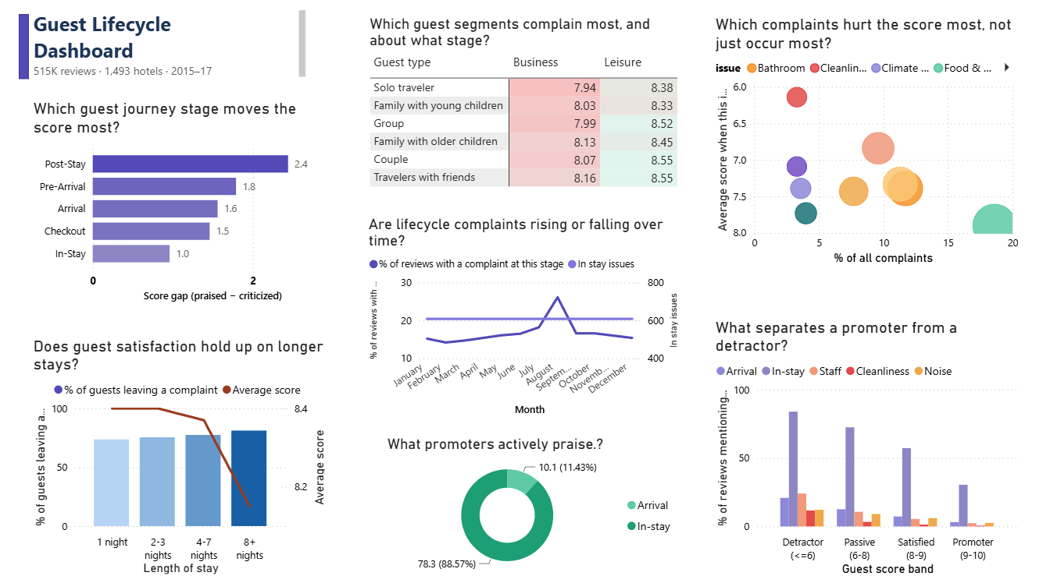

2. Headline Numbers
Metric | Value
Reviews looked at | 515,738
Stage that moves the score most | Post-stay (return intent)
Stage that generates the most talk, but moves score least | In-stay (room, service)
Single worst complaint by score impact | Cleanliness (6.14 avg score)
Toughest guest segment | Solo business travellers (7.94 avg)
Complaint rate: 1 night vs 8+ nights | 73.7% vs 81.2%
Cleanliness complaints: worst guests vs best guests | 11.7% vs 0.4%

3. What We Found, and What To Do About It
1. Post-Stay Experience Has the Greatest Influence on Guest Satisfaction
The analysis shows that post-stay interactions create the largest difference between positive and negative review scores, followed by the pre-arrival experience. Interestingly, while most operational attention is often directed toward the stay itself, in-stay issues produced the smallest impact on overall ratings despite representing the largest share of guest feedback.
This suggests guests are generally willing to overlook minor inconveniences during their stay if the overall journey feels well managed. However, communication before arrival and engagement after departure play a much larger role in shaping how guests remember the experience and whether they are likely to return.
Recommendation
Rather than concentrating improvement efforts solely on operational delivery during the stay, hotels should strengthen pre-arrival communication and post-stay engagement by introducing:
- Automated pre-arrival information and confirmation messages
- Personalised post-stay follow-up emails
- Structured guest feedback collection
- Loyalty and rebooking campaigns
These touchpoints have the potential to improve guest perception without requiring significant operational investment.

2. Cleanliness Is the Most Damaging Issue Despite Low Complaint Volume
Cleanliness accounts for only a small proportion of total complaints, yet it is associated with the lowest average review scores in the dataset. In contrast, food and beverage issues appear much more frequently but have a considerably smaller effect on overall satisfaction.
This indicates that guests perceive cleanliness as a fundamental expectation rather than a service enhancement. A single cleanliness issue can undermine confidence in the property's overall quality and outweigh several positive service interactions elsewhere during the stay.
Recommendation
Housekeeping quality assurance should focus on preventing recurring cleanliness failures through:
- Routine room quality audits
- Supervisor spot inspections
- Trend monitoring for repeat issues
- Additional coaching where recurring patterns emerge
Because cleanliness complaints are relatively uncommon, even modest improvements could generate a disproportionate improvement in guest satisfaction.

3. Business Travellers Represent the Most Sensitive Guest Segment
Among all guest segments, solo business travellers recorded the lowest average satisfaction scores, while leisure couples consistently reported the highest.
Business travellers typically experience hotels as functional environments rather than leisure destinations. Delays during arrival, room readiness issues or service interruptions therefore have a greater impact on their perception of value because their expectations centre around speed, efficiency and reliability.
Recommendation
Hotels targeting business travel should consider operational improvements such as:
- Priority or express check-in
- Guaranteed room readiness for confirmed business arrivals
- Mobile key solutions
- Faster issue resolution through dedicated service channels
Improving convenience for this segment could significantly increase satisfaction among one of the property's highest-value customer groups.

4. Guest Satisfaction Declines as Length of Stay Increases
The analysis reveals a gradual increase in complaint rates as guest stays become longer, accompanied by a steady decline in review scores.
Rather than indicating a single operational failure, this pattern suggests that service consistency becomes increasingly difficult to maintain over multiple days. Minor housekeeping issues, maintenance delays or communication gaps accumulate over time and become more noticeable to long-stay guests.
Recommendation
Hotels should introduce structured mid-stay service recovery initiatives for extended stays, including:
- Courtesy calls after several nights
- Mid-stay room quality inspections
- Proactive housekeeping follow-ups
- Early identification of unresolved maintenance requests
Addressing issues before checkout provides opportunities to recover the guest experience while the stay is still in progress.

5. Complaint Trends Suggest Operational Drift Over Time
The dataset indicates a gradual increase in both arrival-related and in-stay complaints across the reporting period.
Although the increases are not dramatic individually, together they suggest that operational performance may slowly deteriorate when guest feedback is monitored retrospectively rather than continuously.
This highlights the importance of treating guest feedback as an operational performance indicator rather than solely a customer satisfaction metric.
Recommendation
Hotel leadership should establish a recurring guest experience review process using lifecycle-based reporting to monitor trends across:
- Arrival
- In-stay
- Checkout
- Post-stay
Regular monitoring enables emerging issues to be identified before they develop into persistent operational problems.

4. Conclusion
This analysis demonstrates that improving guest satisfaction is not simply about reducing the number of complaints. It is about identifying which operational moments have the greatest influence on guest perception and prioritising improvement efforts accordingly.
The findings suggest that relatively targeted operational changes, particularly around communication, cleanliness, business traveller experience and long-stay service consistency, have the potential to generate meaningful improvements in guest satisfaction while making more effective use of operational resources.

5. Methodology
- Analysed 515,738 guest reviews across 1,493 hotels
- Reviews were grouped into key stages of the guest lifecycle:
  - Pre-arrival
  - Arrival
  - In-stay
  - Checkout
  - Post-stay
- Complaint themes were compared against average guest ratings to evaluate both complaint frequency and business impact.
- Operational recommendations were developed using observed patterns within the dataset and industry best practices.

